**Question 14.1**

* Simple Statistics and Correlation Matrix: Since the data is normalized, the mean for all variables is 0 and the standard deviation is 1. The correlation matrix shows the correlation between each variable. The correlation matrix shows the relationship between the two respective variables.

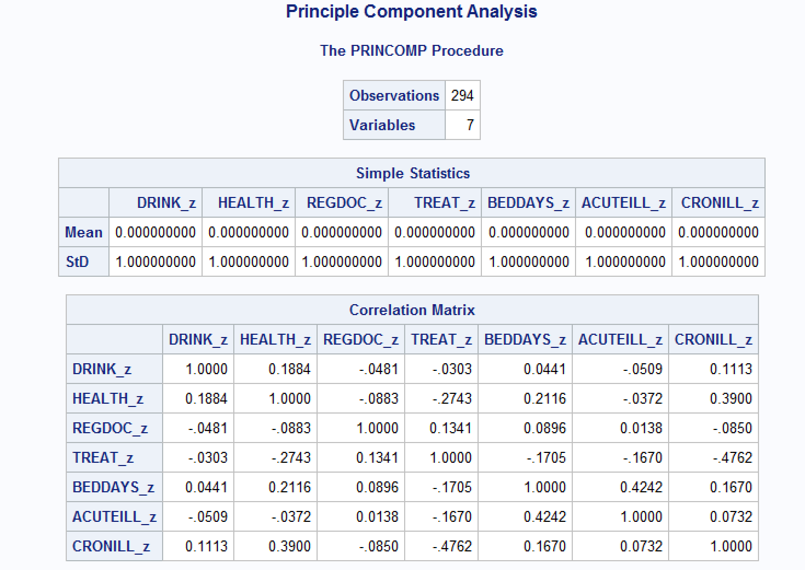

* Eigenvalues and EigenVector
  + Eigenvalue - Variances of the principal components. Total variance equals the number of variables, 7.
  + Difference - Gives the difference between the next eigenvalue.
  + Proportion - Proportion of total variance for each factor.
  + Cumulative - Sum of the proportion column as it increases.
  + Minimum Eigenvalue Criterion
    - Eigenvalues over 1. Only 1-3 retained
    - Scree-plot: Where curvature changes.
    - Retain components that explain 70% to 80% cumulative percent of variance. Retain 1 - 3 or 4
  + EigenVector - Coefficients of principal component score. Represents the weight of the component for each variable, i.e the correlation between a variable and component.

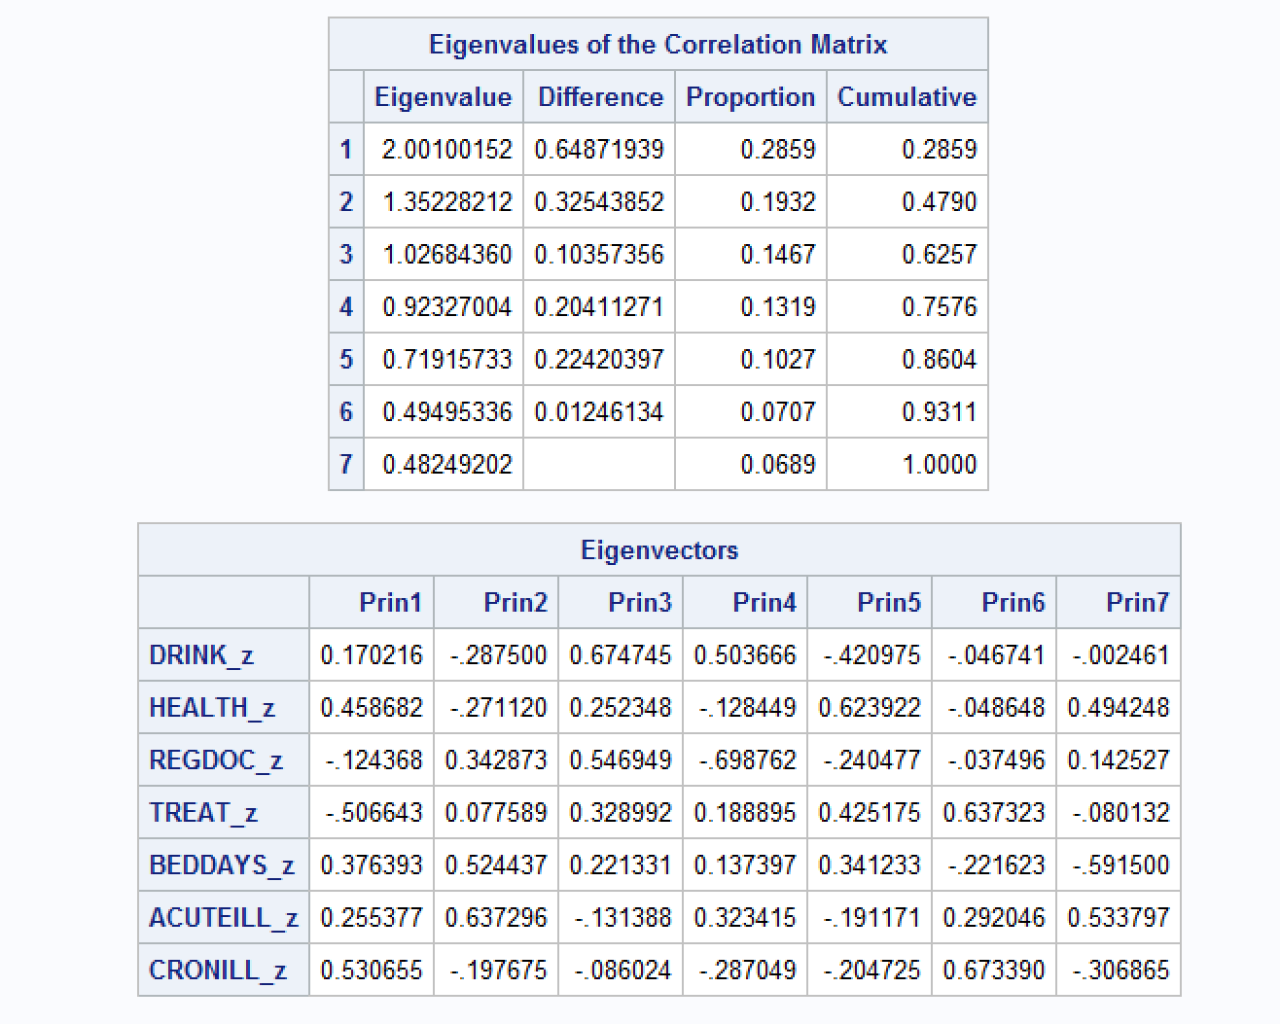

* The scree plot graphs the eigenvalue against the component number. It shows that the eigenvalue of the first component is approximately 2 and the eigenvalue of the second component is 1.3. The variance explained plot shows that the first four principal components account for nearly 80% of the total variance. The line does not flatten as significantly as other models, but starts to taper off after the third component.

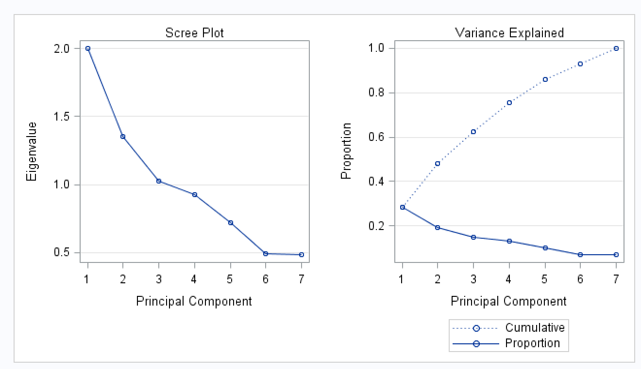

* The first component reflects overall performance, because the first eigenvector shows approximately equal loadings on all variables. The second eigenvector has high positive loadings on the variables Observational Skills and Willingness to Confront Problems but even higher negative loadings on the variables Interest in People and Interpersonal Sensitivity. This component seems to reflect the ability to take action, but it also reflects a lack of interpersonal skills. The third eigenvector has a very high positive loading on the variable Physical Ability and high negative loadings on the variables Problem Solving and Learning Ability. This component seems to reflect physical strength, but it also shows poor learning and problem-solving skills.
* Matrix plot of component scores - The histogram of each component is displayed in the diagonal element of the matrix. The other plots represent the relationship between each two components.

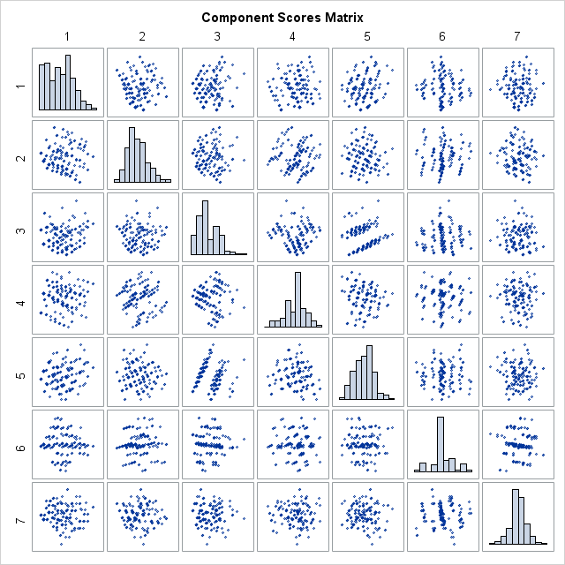

**Question 14.6**

**Correlation Analysis**

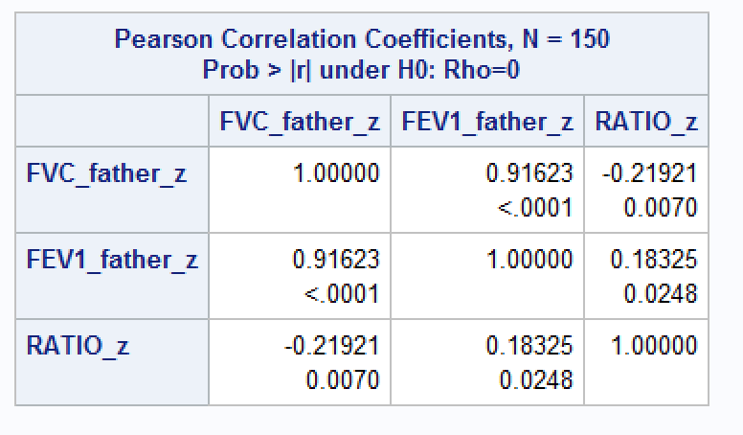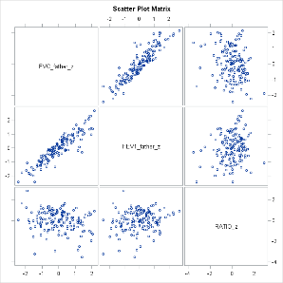

**Principle Component Analysis**

**FEV1_Father and FVC_Father**

* Simple Statistics and Correlation Matrix:
  + Since the data is normalized, the mean for all variables is 0 and the standard deviation is 1. The correlation matrix shows the correlation between each variable. It seems like these two variables are very highly correlated.

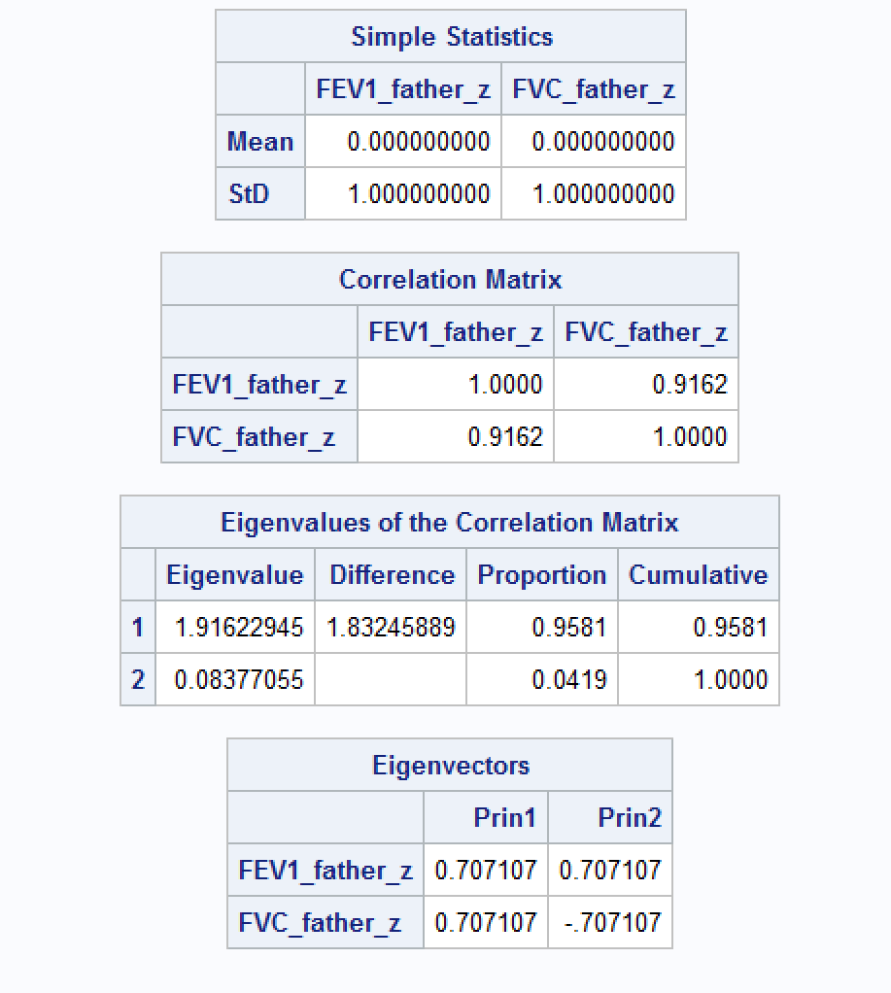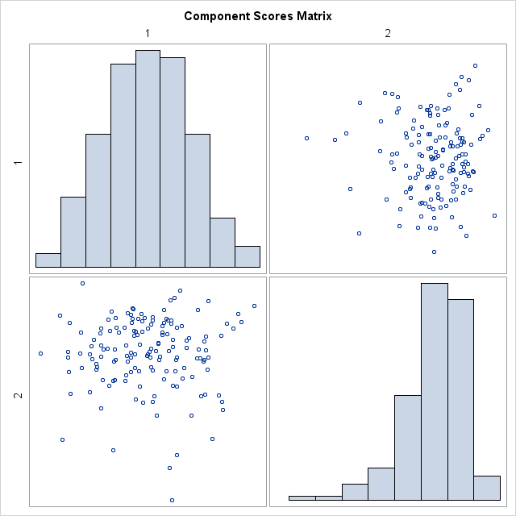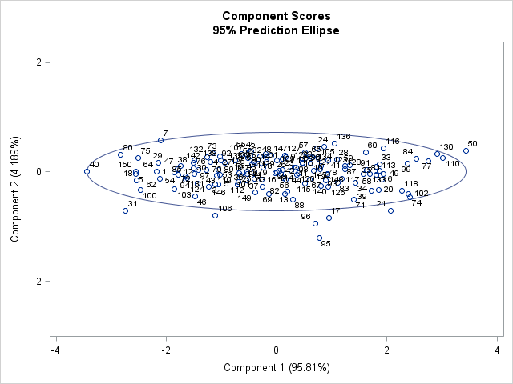

* Eigenvalues and EigenVector
  + Eigenvalue - Total variance = 2.
  + Difference – Large drop off between the two variables
  + Proportion – First component explains 95% of the variance.
  + Minimum Eigenvalue Criterion
    - Eigenvalues over 1. Only 1 retained
    - Scree-plot: No curvature since only two components
    - Only component 1 explains 70% to 80% of cumulative percent of variance.
  + EigenVector - Weight of the component 1 – each variable at .71. Weight of component 2 – Variable 1 = .71, Variable 2 = -.71

**RATIO, FEV1_Father and FVC_Father**

* Simple Statistics and Correlation Matrix:
  + Since the data is normalized, the mean for all variables is 0 and the standard deviation is 1. The correlation matrix shows the correlation between each variable. It seems like the Ratio variable is not highly correlated with any variable.

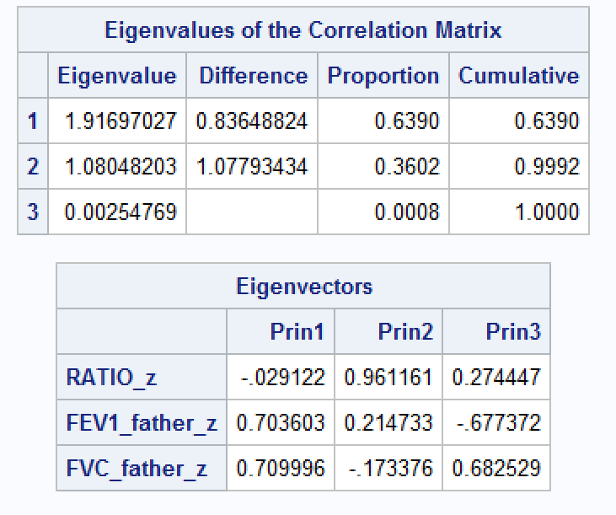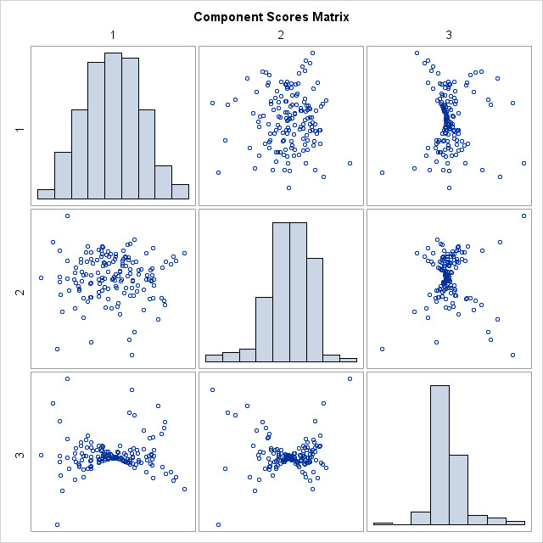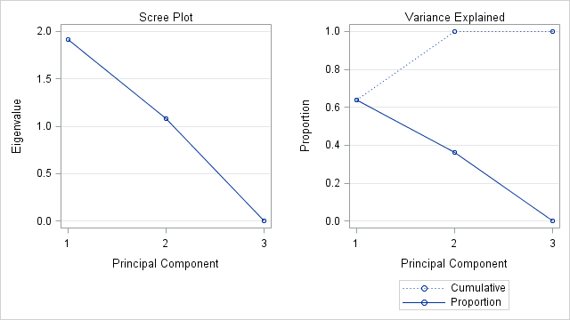

* Eigenvalues and EigenVector
  + Eigenvalue - Total variance = 3.
  + Difference – Large drop off between the two variables
  + Proportion – First two components explain 99% of the variance.
  + Minimum Eigenvalue Criterion
    - Eigenvalues over 1. First 2 retained
    - Scree-plot: No curvature, but variance explained shows third variable as not influential to variance
    - Two components explain 70% to 80% of cumulative percent of variance.
  + EigenVector –
    - 1st Principle Compent highly correlated with second two variables
    - 2nd Principle Component highly correlated with Ratio
    - 3rd Principle Component highly correlated with second two variables

**Question 14.7**

* Simple Statistics and Correlation Matrix:
  + Since the data is normalized, the mean for all variables is 0 and the standard deviation is 1. The correlation matrix shows the correlation between each variable. It seems like all three variables are very highly correlated.

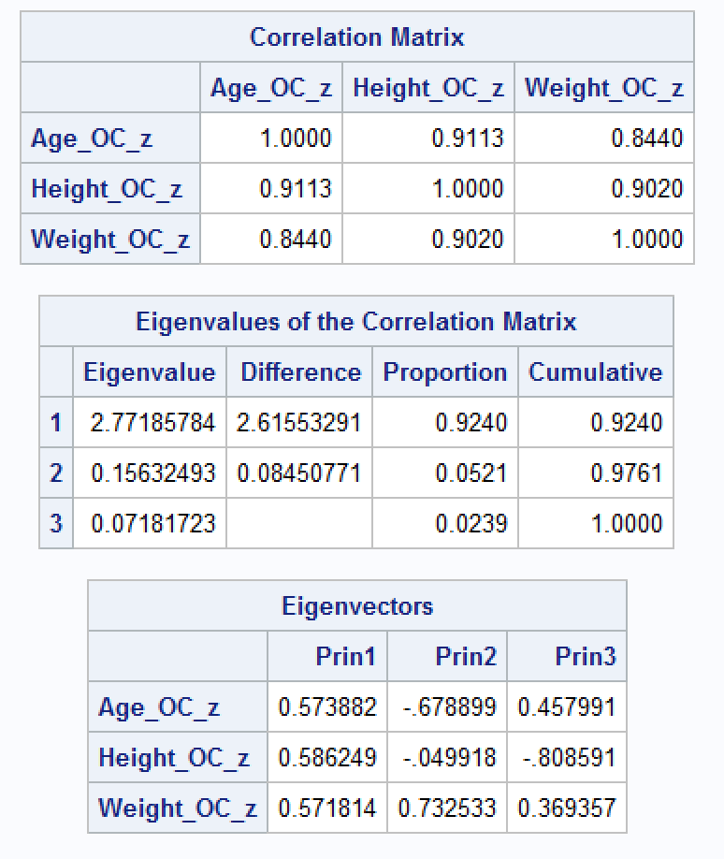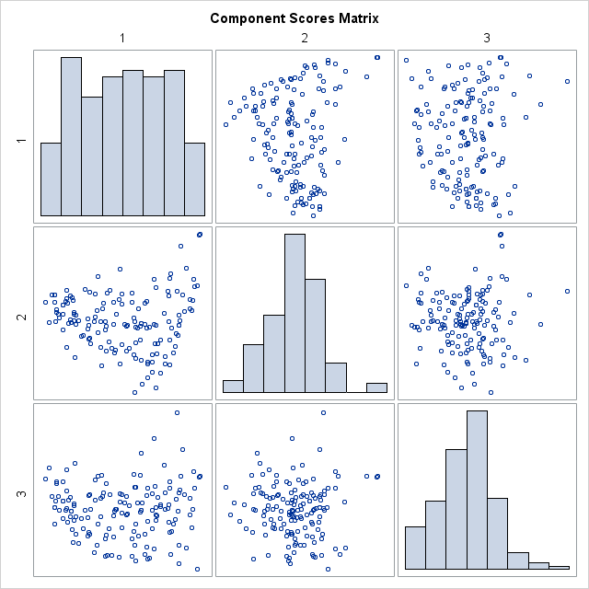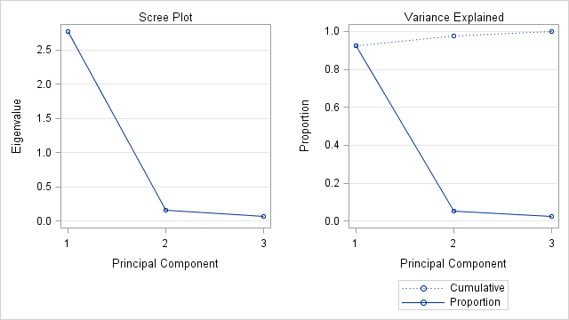

* Eigenvalues and Eigenvector
  + Eigenvalue - Total variance = 3.
  + Difference – Large drop off after the first variable
  + Proportion – First component explains 92% of the variance.
  + Minimum Eigenvalue Criterion
    - Eigenvalues over 1. Only 1 retained
    - Scree-plot: The curvature implies that only the first component is retained
    - Only component 1 explains 70% to 80% of cumulative percent of variance.
  + Eigenvector –
    - Weight of component 1 – Equally correlated with each variable.
    - Weight of component 2 – Highly correlated to age and weight
    - Weight of component 3 – Highly correlated to height